2. The Problem
You guess that the differences in color among the types of plants are due to differences in pigment chemistry, and tomorrow you will test your hypothesis by performing chromatography, a procedure that will allow you to separate and quantify plant pigments. You also guess that being different colors may affect other aspects of the biology of the plants. One difference might be in their ability to survive to reproduce (set seeds). Unfortunately, though, during your picnic you didn’t think to count the numbers of the different types of plants. This information could have given you some idea of which types are most successful in the wild. Today, though, you can count how many of each type of plant you have to determine their frequency? Be sure to assign a phenotype to each of your plants by writing the phenotype on its little pot (NP for purple, I for intermediate and C for non-purple).

Group/treatment _______________________________

Frequencies of deep purple, light purple, and non-purple plants

PHENOTYPE | number | frequency
deep purple (P) 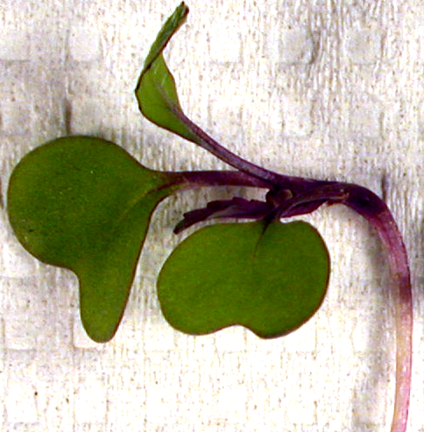
intermediate purple (I)
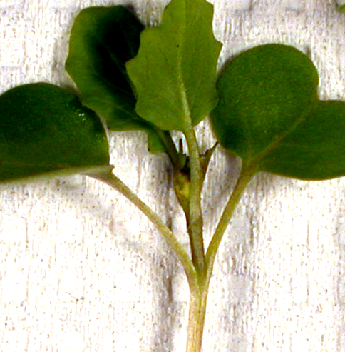
non-purple (NP) 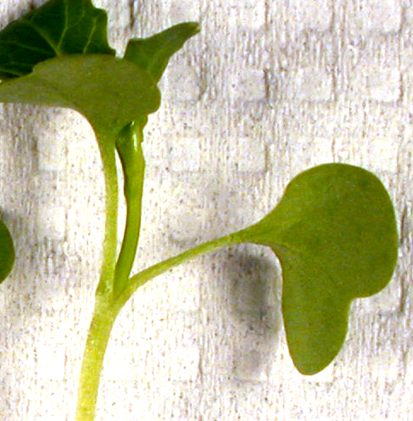
total |  | 1.0
Selection
Now that you know the frequencies of the types in your flat, you can see whether natural selection might favor one type over the others. Plants in nature are subjected to all kinds of forces that can affect their growth and survival. Such sources are called agents of selection. How many such sources can you think of?

Some of the plants have already been exposed to one very common force affecting plant growth and survival—insect herbivores. If your plant has an “C” on the side of its cup, it may have eggs or even larvae on it (check the plant over carefully, particularly the underside of the cotyledons, but don’t hurt the eggs or larvae you find).

There is another factor that some of your plants have been subjected to—low light level. These plants are marked with “L”.

All “H” plants were grown at high light without herbivores.

We will see in coming days what effect these potential selection agents (insects, low light and high light) might have on the fitness of the different phenotypes.

